Onesystemshelldredd
Proving Grounds
Penetration Test Report

Table of Contents
- High-Level Summary………………………………………………………………………………………………………………………….3
  - Recommendations..………………………………………………………………………………………………………………3
- Methodologies………………………………………………………………………………………………………………………………….4
  - Information Gathering………………………………………………………………………………………………………….4
  - Service Enumeration…………………………………………………………………………………………………………….4
  - Penetration…………………………………………………………………………………………………………………………..4
System Vulnerable……………………………………………………………………………………………………………….6
2.4-Report…………………………………………………………………………………………………………………………………..7

1.0-High-Level Summary
An internal penetration test was performed on the Onesystemshelldredd network in the Offensive Security Proving Grounds Labs. An internal test simulates an attacker that is directly connected into the network, in this case through a VPN tunnel.
The purpose of this test was to simulate an attack where the attacker had access to the network, with attempts made to break into a system and then elevate privileges on the machine. Over-all, the intent was to enumerate the services on the exposed network, determine an attack vector to get access, and then exploit any flaw found within the system.
During the test, it was found that allowing anonymous connections to the ftp server lead to the discovery of a ssh key. With this key, it was possible to remotely log in to the device on the ssh moved port without needing to authenticate to the system. Once there, two different SUID enabled files allowed for access to root capabilities, which included getting the hashes of root and other users.

1.1-Recommendations
It is recommended to disable the anonymous login permissions that currently exist on the ftp server. This was the primary weak point that allowed everything else to occur. It is also recommended to remove any credentials or keys that are stored on the ftp server, in the event someone gains a valid user and is able to brute force into the ftp server.
Following that, the SUID enabled files of cpulimit and mawk should have their SUID setting removed, as these files allow for root enabled commands and access that fully compromised the system. Removing these exploit vectors will increase the security of your network.

2.0-Methodologies
Below is the methods that were undertaken to break into the device, and ultimately achieve root access on the device.

2.1-Information Gathering
The information gathering portion was mostly null, as the network address of 192.168.191.130 was provided ahead of the pentest commencing.

2.2-Service Enumeration
Checking the TCP ports, it was found that there were two services open running on the following ports:
21 FTP server
61000 Secure Shell remote access

2.3-Penetration Testing
Once the results of the port scanning were returned, immediately check to see if anonymous login was possible on the ftp server. With login success, I was able to locate a ssh key that was stored on the server.
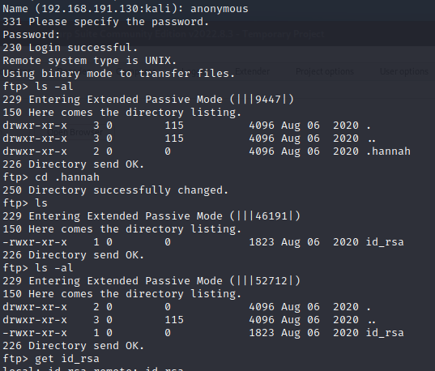
With the id_rsa key, it was possible to log in through secure shell to the device, and have user level control of the machine. This also lead to gaining the contents of the local.txt file.
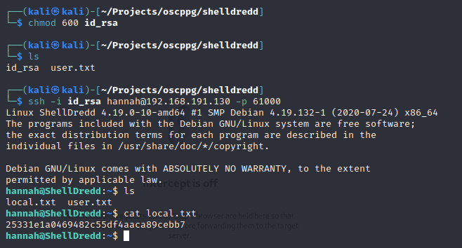
For privilege escalation, the SUID set files on the system were checked, and 2 were found to be vectors for escalating privilege to root level.
The first one used gave a full root shell that gave access to all sections of the device, allowing for complete control of it. This was then used to capture the contents of the proof.txt file.
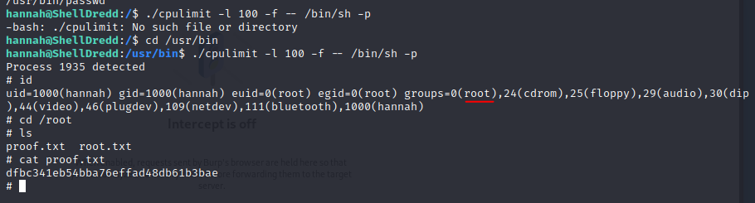
While that method gave root access to the machine, I circled back and checked the second vector that allowed for reading the contents of files with root level access. Verifying this method also worked, I was able to get the hashes of the root account and users, along with reading the contents of the proof.txt file through it as well.
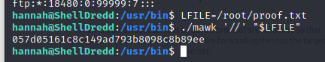
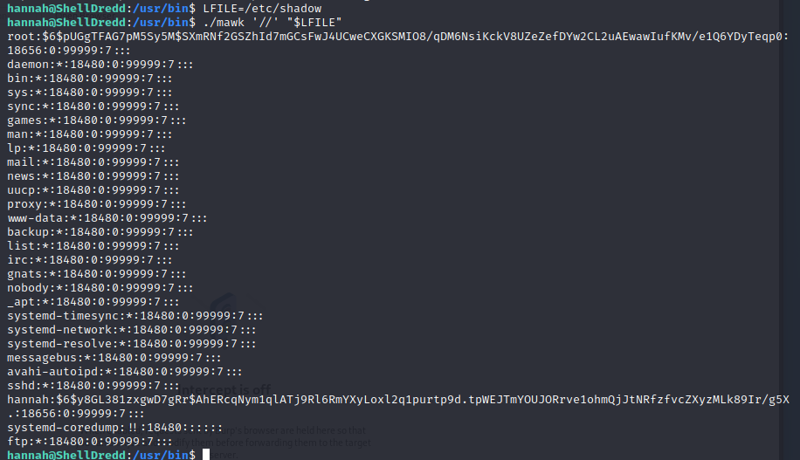

System Vulnerable 192.168.191.130

Vulnerabilities Exploited:
Anonymous login allowed on FTP server
Secure credentials stored on FTP server
SUID enabled files allowing for root access
Vulnerability Fixes:
Remove unauthenticated access to the FTP server
Remove all credentials from the FTP server
Remove SUID settings from cpulimit and mawk
Severity: Critical
Proof of Privilege Escalation:
Local.txt: dfbc341eb54bba76effad48db61b3bae
Proof.txt: 057d05161c8c149ad793b8098c8b89ee

2.4-Report: Clean-up
Linpeas.sh was uploaded to the /tmp file, and then removed. There were no other files that were uploaded or manipulated during this penetration testing.

